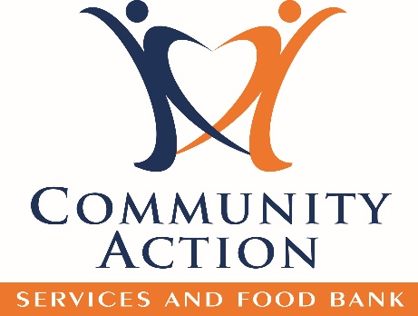

* Turkeys & Hams
* Spaghetti Sauce
* Cereal - hot or cold
* Rice
* Flour

**Community Action Services and Food Bank**

**801-373-8200**

**815 S. Freedom Blvd. Provo, UT**

**www.communityactionprovo.org**

**Every $1 donated feeds a family for a day!**

&

**November 15-30 2020**

**Location:**

**Needed Items:**

* Peanut Butter
* Baby Supplies
* Toiletries
* Pasta
* Baking Goods

445 Food Drive Lane

American Fork, UT 84503

Barrels are located through the building

**Join us to *CAN* hunger!**